Adept 10.1 API Changes
September 2016
Synergis Technologies

Contents
Introduction 4
The Ribbon Bar 4
Single Document Interface 5
Unified Status Bar 5
API Additions and changes 6
A Note about Localization 6
“Get” routines 6
long CGuiApi::GetRibbonTabCount() 6
long CGuiApi::GetRibbonPanelCount(long tabIndex) 6
long CGuiApi::GetRibbonButtonCount(long tabIndex, long PanelIndex) 7
long CGuiApi::GetRibbonButtonMenuItemCount(long tabIndex, long PanelIndex, long ButtonIndex) 7
BSTR CGuiApi::GetRibbonTabText(long tabIndex) 7
BSTR CGuiApi::GetRibbonPanelText(long tabIndex, long PanelIndex) 7
BSTR CGuiApi::GetRibbonButtonText(long tabIndex, long PanelIndex, long ButtonIndex) 7
BSTR CGuiApi::GetRibbonButtonItemText(long tabIndex, long PanelIndex, long ButtonIndex, long ItemIndex) 7
Update Command 7
long CGuiApi::UpdateRibbonBar() 7
“Add” Commands 8
long CGuiApi::AddRibbonButtonCommand(LPCTSTR TabName, LPCTSTR PanelName, long BeforeIndex, LPCTSTR pCommandName, long FAR* NewIndex, long FAR* CommandNumber, int iconIndex) 8
BOOL CGuiApi::AddMenuItemToButton(LPCTSTR TabName, LPCTSTR PanelName, LPCTSTR ButtonName, LPCTSTR pMenuItemName, long *CommandNumber) 9
“Remove” commands 9
long CGuiApi::DoesRibbonButtonExist(LPCTSTR TabName, LPCTSTR PanelName, LPCTSTR ButtonName) 9
long CGuiApi::RemoveRibbonPanel(LPCTSTR TabName, LPCTSTR PanelName) 10
long CGuiApi::RemoveRibbonButton(LPCTSTR TabName, LPCTSTR PanelName, LPCTSTR ButtonName) 10
long CGuiApi::RemoveRibbonButtonMenu(LPCTSTR TabName, LPCTSTR PanelName, LPCTSTR ButtonName, LPCTSTR MenuName) 10

Introduction
Adept 10.1 represented a long awaited face lift to the user interface. The changes in the interface required changes in the API as well, which necessitates this document.

The Ribbon Bar
The Ribbon bar is best known in Microsoft Office applications. There are several terms for different parts of this interface. We will use the following terms:
- Ribbon bar identifies the entire top portion of the application, including the application button (sometimes called the back-stage button) the small toolbar at the top (QAT or quick access toolbar ;) and the block of objects below that, including tabs, panels, buttons, and menus.
- Ribbon Tabs are similar to those controls at the bottom of Excel. Changing a tab changes all the button, panels, and menus assigned to that tab. Adept allows the user to create custom tabs, as well as to show or hide tabs. We tend to call the standard set of tabs the system tabs.
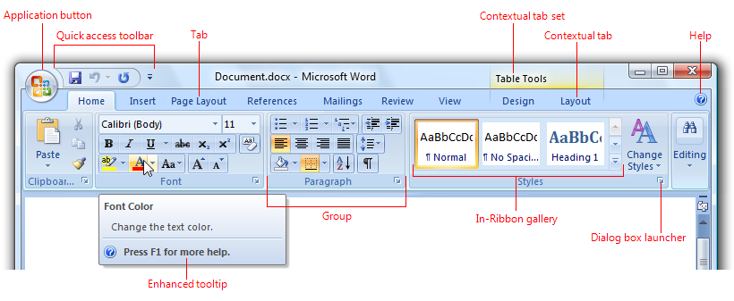
- Panel. On each tab are a collection of controls. There is a Group, or Panel, which encloses buttons, each of which have custom graphics.
- Buttons are a combination of text and a graphic, and reside inside a panel on a tab.
- Menus can be attached to a button, and can also have a small graphic image associated with the text of the menu item.
Here’s the Adept Ribbon Bar.
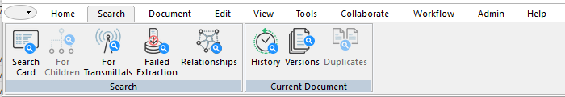
There are ten tabs (this is the Search tab), and on each tab one or more panels, each of which has one or more buttons. A menu can be attached to a button, which then has a small triangle indicator, as shown below.
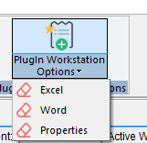

Single Document Interface
A second change in Adept 2017 is there is now only a single “window” showing at all times. This window contains a tree view on the left, and a list view on the right. We also created independent views for inbox, FileGuide, library browser, and Favorite FG view.

Unified Status Bar
At the bottom of Adept’s interface, there is a unified status bar which contains buttons to switch from one view to another. The following views exist:
- Favorites
- FileGuide
- Inbox
- Library Browser
- Search Result
- Work Area
In addition to these button at the top of the status bar, there are small buttons that were also present in Adept 2015:
- Information Source
- Work area
- Library Set
- System Tab set
Additionally, to the right are various status text displays, each of which is displayed in Italics, and which cannot serve as a button.

API Additions and changes
There was already a series of calls that were menu based. Essentially all of these calls are depreciated since Adept no longer has a main menu. I did write code that converts menu calls to ribbon calls, but be prepared to have all the menu calls stop working at some point.
As stated, no calls have been made obsolete, but please convert all menu calls to ribbon calls. We may obsolete the menu calls at any time, since they no longer have any real meaning.
All of these calls are GuiApi calls. The addition to the API provides all the functionality needed to create custom tabs, panels, buttons, and menus for the Adept user.
In addition, commands (buttons or menus) created this way are now available for the user to use in custom ribbon tabs. This is a powerful way to simply the user interface. Rather than search through menu after menu, the user could have a single button that has the same functionality in a simple easy to user interface.

A Note about Localization
Before the user logs in, Adept builds tables of the English strings, before any localization is applied. All of the Get Text routines will return the English string, before any localization is done. This means that the API programmer doesn’t need to worry about the localization of the rest of Adept.

“Get” routines
These routines either return the count of something, or the text associated with something.

long CGuiApi::GetRibbonTabCount()
This routine returns the count of tabs on the ribbon bar. Since most plugins are initiated during login, this count typically does not include custom tabs, although if the plugin is reloaded after a user is using Adept, the count could include custom tabs.
0 is the error return, although I don’t see how there should be any error.

long CGuiApi::GetRibbonPanelCount(long tabIndex)
Ribbon tabs are indexed using zero based indexing. Panels are used to enclose buttons, in a sort of group box manner.
An error return would be 0, since that’s not possible – every tab always has at least one panel. Error is most likely due to an improper index.

long CGuiApi::GetRibbonButtonCount(long tabIndex, long PanelIndex)
A panel encloses buttons, which are the main basis of the ribbon user interface. As the API programmer iterates through the ribbon, this call returns the number of buttons enclosed by the specified panel.
An error return would be a zero.

long CGuiApi::GetRibbonButtonMenuItemCount(long tabIndex, long PanelIndex, long ButtonIndex)
Some buttons contain an associated menu. This call is the main way the API programmer would find the associated menu.
If the return value is 0, there is no menu.

BSTR CGuiApi::GetRibbonTabText(long tabIndex)
This routine returns the text associated with the specified tab. As stated in the introduction, if custom tabs are loaded, this would return the text of the custom tab.
An error return would be an empty string.

BSTR CGuiApi::GetRibbonPanelText(long tabIndex, long PanelIndex)
This routine returns the text associated with the specified panel on the specified tab.
An error return would be an empty string.

BSTR CGuiApi::GetRibbonButtonText(long tabIndex, long PanelIndex, long ButtonIndex)
This routine returns the text associated with the specified button, on the specified panel on the specified tab.
An error return would be an empty string.

BSTR CGuiApi::GetRibbonButtonItemText(long tabIndex, long PanelIndex, long ButtonIndex, long ItemIndex)
This routine returns the text associated with the specified menu item on the specified button, on the specified panel on the specified tab.
An error return would be an empty string.

Update Command
The ribbon does not update automatically.

long CGuiApi::UpdateRibbonBar()
This command will cause the ribbon to redraw itself. Use this command after adding tabs, panels, buttons, and or menus.

“Add” Commands

long CGuiApi::AddRibbonButtonCommand(LPCTSTR TabName, LPCTSTR PanelName, long BeforeIndex, LPCTSTR pCommandName, long FAR* NewIndex, long FAR* CommandNumber, int iconIndex)
This command is very powerful, use with caution.
The caller should pass the desired names of Tab, Panel, and Button. Please note that if the Tab name isn’t found, a new Tab by that name is created. Also if the Panel name isn’t found on the specified tab, then a new Panel will be created.

Separators
A Separator can be created by calling with an empty button name.
If a button name by the same name already exists on the panel, it is removed, and the new button is added.

Button Position
The caller can specify the order the button will appear on the panel by specifying the before index. If the panel has four buttons, a before index of 3 would create the button in the second position.
The return value of “new index” is the position of the new button on the panel.

Command Number
The return index of command number is the command number that will be sent each time the button is pressed. This should normally call the reactor code you’ve associated with the button.

Icons
There are around 200 icons reserved for buttons. The last parameter of the API call allows the caller to specify which icon will be created on the ribbon.
Rather than attempt to create a document to show each icon, I created a special backdoor way to see the index for each icon in the system.
Bring up the Tab manager by selecting it from either the context menu on the ribbon, or from the application button (back door button) on the top left of Adept.
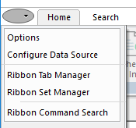
Once the tab manager appears, prepare the following key combinations:
Control + Shift + Alt. Now click on “New Custom Tab.” When these key combinations are seen, the icon section of the custom tab editor display information specifically for the API programmer.
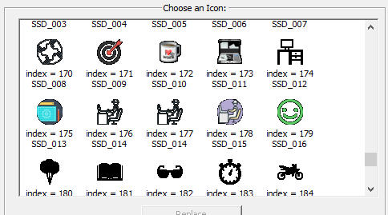
As you see by the graphic, the index associated with each icon is displayed. For example, if you selected index 179 – you would create a button with the green smiley face icon associated with it.

BOOL CGuiApi::AddMenuItemToButton(LPCTSTR TabName, LPCTSTR PanelName, LPCTSTR ButtonName, LPCTSTR pMenuItemName, long *CommandNumber)
This call allows the API programmer to add a menu item to a ribbon button.
Again, this is very powerful. If the tab or panel or button does not exist, they will each be created.
The menu item is then appended to the menu, and the command number is returned.

“Remove” commands
The following calls are provide to allow the API program to remove commands that were added via the API.

long CGuiApi::DoesRibbonButtonExist(LPCTSTR TabName, LPCTSTR PanelName, LPCTSTR ButtonName)
This call is a good test to call before removing a command.
The call includes tab, panel, and button name. If all three of these exists, then the call returns TRUE. If any of these don’t exist, then the call returns FALSE.
long CGuiApi::RemoveRibbonTab(LPCTSTR TabName)
This call will remove the specified ribbon tab, along with all the panels, buttons, and menu items contained on that tab.
If the specified Tab isn’t found, no action will be taken.
Clearly this is very powerful, so should be used with caution.

long CGuiApi::RemoveRibbonPanel(LPCTSTR TabName, LPCTSTR PanelName)
This command will remove the specified Panel from the specified tab, along with all the buttons and menus on that panel.
If the tab and/or panel isn’t found, no action is taken.
Again, this is very powerful and should be used with caution.

long CGuiApi::RemoveRibbonButton(LPCTSTR TabName, LPCTSTR PanelName, LPCTSTR ButtonName)
This call will remove the specified button from the specified tab and panel.
If the tab and/or panel/or button isn’t found, no action is taken.

long CGuiApi::RemoveRibbonButtonMenu(LPCTSTR TabName, LPCTSTR PanelName, LPCTSTR ButtonName, LPCTSTR MenuName)
This call will remove the specified menu item from the specified tab, panel, and button.
If the tab/panel/and or button isn’t found, no action will be taken.

Sample Plugin – Hello Ribbon
I created a very simple plugin to illustrate the API calls to create custom ribbon tabs, buttons, and menus.
One of the CSharp projects under SDK10 Examples is called “AP_HelloRibbon”
If you build this, register the resultant DLL, then add the plugin to Adept’s list of plugins, you’ll see how custom ribbon tabs, buttons, and menus can be added to the Adept Desktop set of ribbon tabs.
It’s very simple, but it contains the building blocks you will use to create more complex programs.

A note about icon indexes
The ribbon API calls include a parameter to specify which icon index the button should use. There is sort of a problem, since how do you know which icon to use?
Rather than have a long list of icon indexes, which would grow obsolete over time, I put in what I call a backdoor that will display all the icons with their associated index.
First bring up the desktop client, then bring up the Ribbon Tab Manager. Hold down three keys at the same time – CONTROL and ALT and SHIFT – and then click on the “New Custom Tab” button.
These three keys open a backdoor which will now show the custom tab UI, but where the icons shown (bottom left of the dialog) I’ve added a line to show the index. The icons are shown in index order – and using the # shown by an icon will display the associated icon. You can scroll through the icons to find one that is interesting to you. There are currently 203 icons, but expect that number to continue to grow over time. Ignore the “name” attached to each icon – I use the name to make sure I have the correct icon.
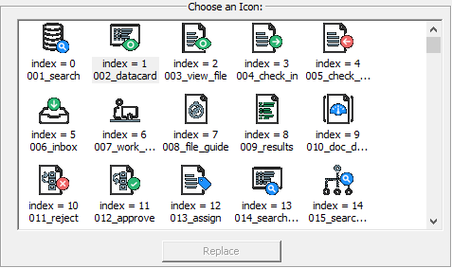
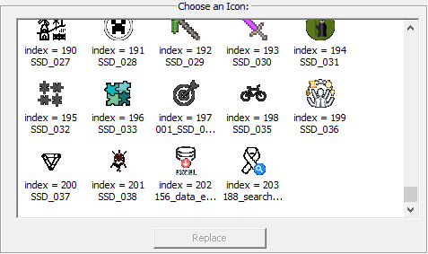

Creating a custom ribbon tab
The following code adds a button with the text “Hello Ribbon Button” on a new custom tab named “Hello Ribbon” inside a panel named “Ribbon Panel One.”
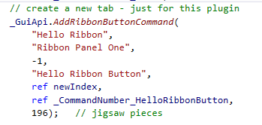
Note, the icon index of 196 will use this icon:
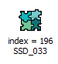
The -1 indicates we don’t care about the order of buttons on the panel (since there is only one.) The returned index “newIndex” isn’t saved, since this program doesn’t use it.
The command number of this button is returned in _CommandNumber_HelloRibbonButton.
Here is the new custom tab with the single button and panel created as requested in the call:
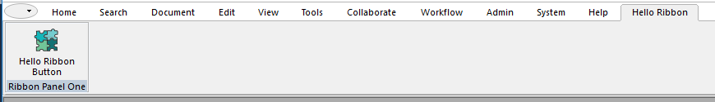
Clicking on the button currently does this:
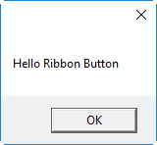
Directed so by this code:
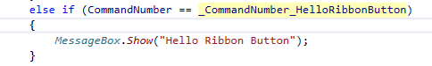
In the begin custom command event code.
Clearly you can create your desired code in place.

Adding a menu item to a button
I added a menu pick to the help tab
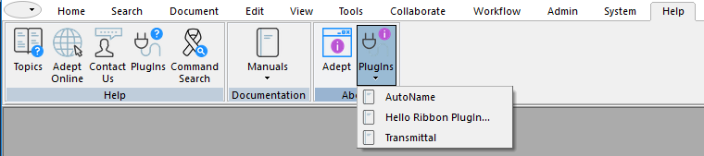
Using the following code:
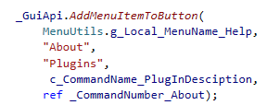
Note there is no icon index currently available via the API.

Adding a button to an existing system tab
I added a button to an existing system tab:
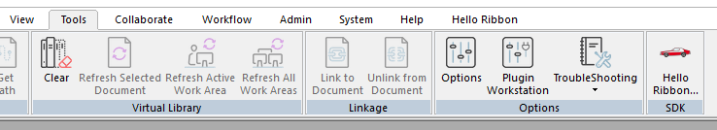
Using the following code:
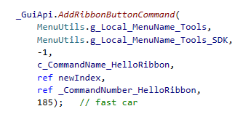
Again – if you use the back door to get icon indexes, you can see that 185 is a fast car:
